**Numerical Computation - Assignment 3**

**薛劭杰 1930026143**

1. (I)

(a): $x^{5}+x=1$**. Let $f\left(x\right)=x^{5}+x-1$. and we should find a point make $f\left(x\right)$ equal to zero. The root must be smaller than and larger than zero** **and the function is continuous in the interval [0, 1]. Let $x_{a}=1 ,x_{b}=0, f\left(x_{a}\right)=1>0 and f\left(x_{b}\right)=-1<0$.** **So, there must exist a point to make $f\left(x\right)=0$. Ans: $\left[0, 1\right]$**

(b): $\sin{x}=6x+5$**. Let $f\left(x\right)=\sin{x}-6x-5$ and we should find a point make $f\left(x\right)$ equal to zero. When $x=0, f\left(x\right)=-5<0.$ When $x=-1, f\left(x\right)=\sin\left(-1\right)+1>0$.** **And the function is continuous in the interval [-1, $0$], So, there must exist a point to make $f\left(x\right)=0$. Ans: $\left[-1,0\right]$**

**(c): $In x+x^{2}=3$. Let $f\left(x\right)=In x+x^{2}-3$ and we should find a point make $f\left(x\right)$ equal to zero. When $x=1, f\left(x\right)=0+1-3=-2$. If $x=2, f\left(x\right)=In2+4-3=In2+1>0$. And the function is continuous in the interval [1, 2]. So, there must exist a point to make $f\left(x\right)=0$. Ans: $\left[1,2\right]$**

(**II)**

**(a): Let $x_{a}=1, x_{b}=0, f\left(x_{a}\right)=1 and f\left(x_{b}\right)=-1$. $x_{1}=(x_{a}+x_{b})/2=0.5$. $f\left(x_{1}\right)=-0.46875<0$. Therefore, we replace $x_{b}$ with $x_{1}$. $x_{2}=\left(x_{1}+x_{a}\right)=0.75$. $f\left(x_{2}\right)=-0.2626<0$. After two steps, we get the approximation root is 0.75.**

**(b): Let $x_{a}=-1, x_{b}=0, f\left(x_{a}\right)≈0.9825 and f\left(x_{b}\right)=-5$. $x_{1}=(x_{a}+x_{b})/2=-0.5$. $f\left(x_{1}\right)≈-2.0087<0$. Therefore, we replace $x_{b}$ with $x_{1}$. $x_{2}=\left(x_{1}+x_{a}\right)=-0.75$. $f\left(x_{2}\right)≈-0.5131<0$. After two steps, we get the approximation root is -0.75.**

**(c): Let $x_{a}=1, x_{b}=2, f\left(x_{a}\right)=-2 and f\left(x_{b}\right)≈1.6931$. $x_{1}=(x_{a}+x_{b})/2≈1.5$. $f\left(x_{1}\right)≈-0.3445>0$. Therefore, we replace $x_{a}$ with $x_{1}$. $x_{2}=\left(x_{1}+x_{b}\right)≈1.75$. $f\left(x_{2}\right)≈0.6221>0$. After two steps, we get the approximation root is 1.75**

1. **Let $f\left(x\right)=x^{3}+x^{2}-1$ and $x_{0}=1$, $f\left(x_{0}\right)=1$. $f^{'}\left(x\right)=3x^{2}+2x.$**

**Step1: $x_{1}=x_{0}+h=x_{0}-\frac{f\left(x_{0}\right)}{f^{'}\left(x_{0}\right)}=1-\frac{1}{5}=\frac{4}{5}$. $f\left(x_{1}\right)=0.152$.**

**Step2: $x_{2}=x_{1}+h=x_{1}-\frac{f\left(x_{1}\right)}{f^{'}\left(x_{1}\right)}=\frac{4}{5}-\frac{0.152}{3.52}≈0.7568$. $f\left(x_{2}\right)≈0.0062$.**

**Therefore, the approximation root for this function is 0.7568.**

1. **According to the Taylor Polynomials, there is a function for the root ‘r’:**

$f\left(r\right)=f\left(x_{k}\right)+f^{'}\left(x_{k}\right)\left(r-x_{k}\right)+\frac{f^{''}\left(ξ\right){\left(r-x_{k}\right)}^{2}}{2!}=0$**, $r<ξ<x_{k}$.**

$\frac{f\left(x_{k}\right)}{f^{'}\left(x_{k}\right)}+\left(r-x_{k}\right)+\frac{f^{''}\left(ξ\right)}{2f^{'}\left(x_{k}\right)}{\left(r-x_{k}\right)}^{2}=0$**, and then:**

$$x_{k}-\frac{f\left(x_{k}\right)}{f^{'}\left(x_{k}\right)}=r+\frac{f^{''}\left(ξ\right)}{{2f}^{'}\left(x_{k}\right)}{\left(r-x_{k}\right)}^{2}→ x_{k+1}=r+\frac{f^{''}\left(ξ\right)}{{2f}^{'}\left(x_{k}\right)}{\left(r-x_{k}\right)}^{2}$$

$So \left|x_{k+1}-r\right|=\frac{1}{2}*\left|\frac{f^{''}\left(ξ\right)}{f^{'}\left(x_{k}\right)}{\left(r-x_{k}\right)}^{2}\right|$ $→ ε_{k}=\frac{1}{2}\frac{f^{''}\left(ξ\right)}{f^{'}\left(x_{k}\right)}*ε^{2}.$

**If $i→∞, x_{k} and ξ tend to the r$, So:**

$f^{'}\left(x\right)=96x^{2}-64x-6$**, $f^{''}\left(x\right)=192x-64$. $r_{1}=-\frac{1}{2}, r_{2}=\frac{3}{4}$. $f^{'}\left(-\frac{1}{2}\right)= 50$ and $f^{''}\left(-\frac{1}{2}\right)=-160$.** **For the $r_{1}=-\frac{1}{2},$ the convergence is quadratic,**

**Since $ε_{i+1}=\frac{1}{2}*-\frac{160}{50}= -1.6{*ε}_{i}^{2}$.**

**For the $r_{1}=\frac{3}{4}, f^{'}\left(\frac{3}{4}\right)=0$. In this case, we could not use this method to**

**Calculate. So, we get to find the $f^{'''}\left(r_{2}\right)=192≠0,f^{'}\left(r_{2}\right)=0$ and $f\left(r_{2}\right)=$**

$0$**which means that $f\left(x\right)=0+0+…+R_{n}=\frac{f^{k}\left(r\right)}{k!}{\left(x-r\right)}^{k}+R_{n}.$**

**Let $g\left(x\right)\frac{f^{k}\left(r\right)}{k!}{\left(x-r\right)}^{k}+R_{n}→N\left(x\right)=x-\frac{f\left(x\right)}{f^{'}\left(x\right)}=x-\frac{\left(x-r\right)g\left(x\right)}{g\left(x\right)+\left(x-r\right)g^{'}\left(x\right)}.$ The $N\left(x\right)=N\left(r\right)+N(ξ)(x-r)$. Therefore, $N^{'}\left(g\right)=lim_{n→∞}\frac{x_{n+1}-r}{x_{n}-r}$ which is a constant, the convergence is linear.**

1. **Let $f\left(x\right)=x^{3}-2x-2$, the initial case is $x_{0}=1 and x_{1}=2$.**

**So, we should iterate step by step:**

$x_{2}=x_{1}-\frac{x_{1}-x_{0}}{f\left(x_{1}\right)-f\left(x_{0}\right)}*\left(f\left(x_{1}\right)\right)=\frac{8}{5}$**, $f\left(x_{2}\right)=-1.104$.**

$x_{3}=x_{1}-\frac{x_{2}-x_{1}}{f\left(x_{2}\right)-f\left(x_{1}\right)}*\left(f\left(x_{2}\right)\right)≈1.7423$**, $f\left(x_{3}\right)≈-0.1958$.**

**Therefore, the approximation root for this function is 1.7423.**

**5.**

**We should satisfy three conditions. The first one is the error should not be larger eps ($\left|x_{a}-x_{b}\right|≤eps*|x_{b}|$). The second one is the limited number of iterations, we cannot exceed the upper limit. The last one is that the result of the final substitute calculation is to be tolerated. ($f\left(x_{k}\right)<tol$).**

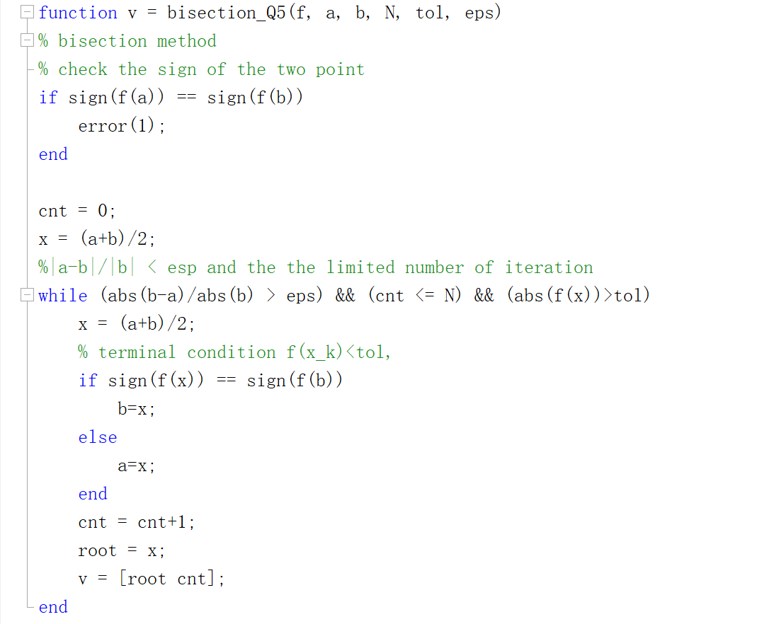

**The first one is the limited number of iterations; we cannot exceed the upper limit. The second one is that the result of the final substitute calculation is to be tolerated. We should pay attention to the case that the function’s derivative is numeric. And deal with the case that no derivative or derivative is equal to zero.**

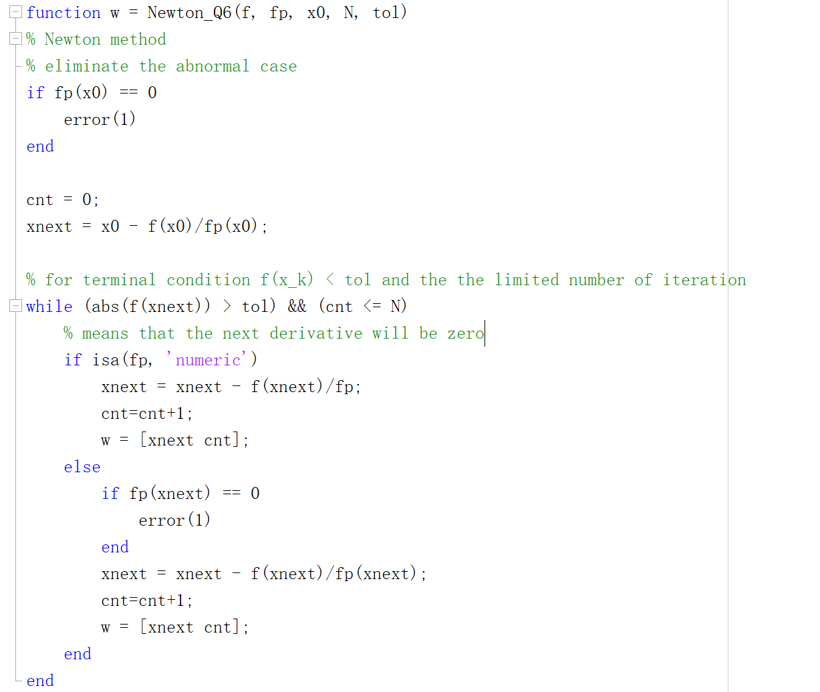

**In this question, we should satisfy three conditions. The first one is the limited number of iterations. we cannot exceed the upper limit.**

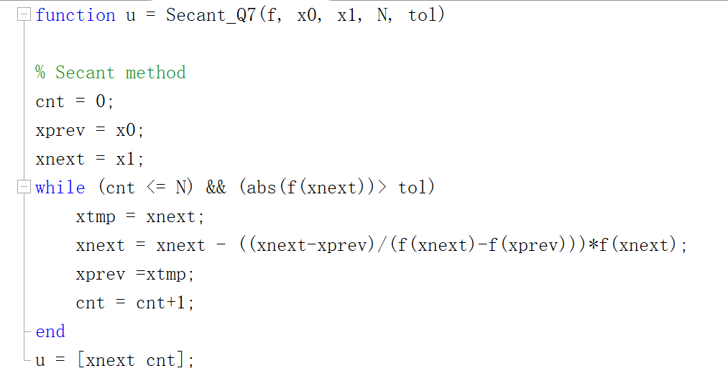

1. **The Bisection method need 10 (maximum) iterations while the Newton method need 2 iterations. The Newton’s method is convergent faster than Bisection.**

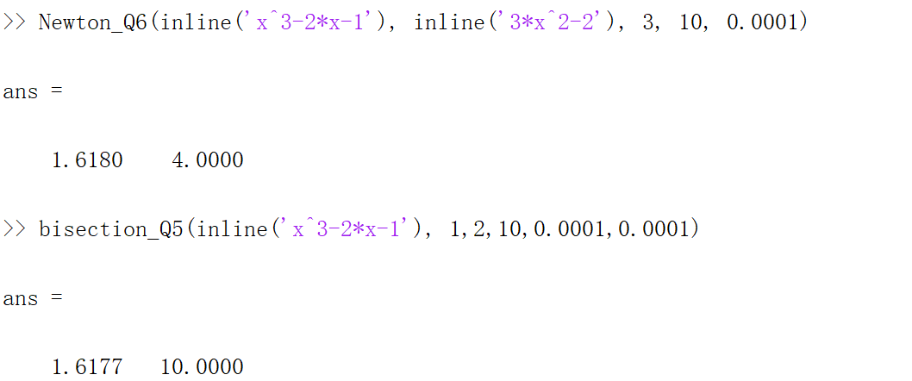

1. **The Secant method need iterate 5 steps while the Newton method need 2 steps.**

**Newton’s method is convergent faster than Secant method.**

